Project Design Phase
Solution Architecture

Date | 15 July 2026
Team ID | SWTID-2026-9567
Project Name | AI Powered Debt Relief & Financial Recovery Platform
Maximum Marks

Solution Architecture
The FinRelief AI solution architecture connects borrowers with an AI-powered financial recovery system through a secure and modular full-stack application. The platform uses React.js for the frontend, FastAPI for backend services, Google Gemini AI for intelligent financial recommendations, and SQLite for secure data storage.
The architecture is designed to:
- Provide AI-powered debt settlement recommendations.
- Analyze borrower financial health.
- Generate negotiation strategies and settlement letters.
- Ensure secure authentication and reliable data management.
- Support future cloud deployment and scalability.
Solution Architecture Diagram 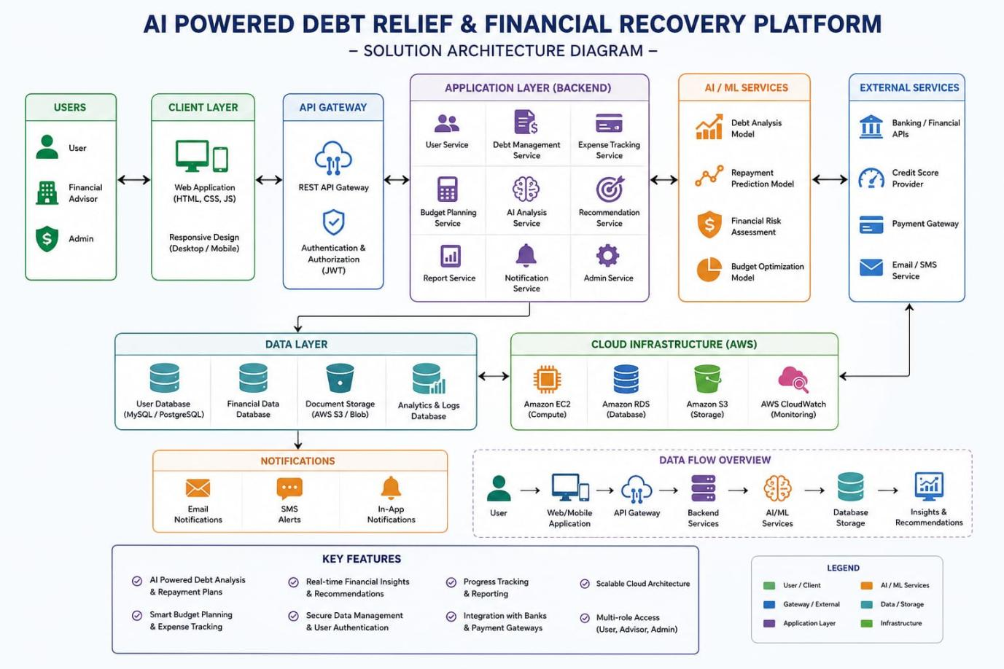

Architecture Components
Component | Technology
Frontend | React.js, HTML, CSS, JavaScript, Vite
Backend | Python, FastAPI, Uvicorn
AI Engine | Google Gemini API
Database | SQLite, SQLAlchemy
Authentication | JWT
API Communication | Axios, REST APIs

Workflow
- Borrower logs into the platform.
- Financial and loan details are submitted.
- FastAPI processes the request.
- Financial engine calculates borrower metrics.
- Google Gemini generates settlement recommendations and negotiation strategies.
- Results are stored in SQLite.
- Financial insights are displayed on the dashboard.

